**Muhammad Naeem 18K-1140**

**Muhammad Faseeh 18K-1128**

**Course Instructor: Dr. Atif Tahir**

**Course: Design and Analysis of Algorithms**

Dynamic Programming Algorithms Visualization

1. **Abstract**

The project aims at building a high-level language and provides a Graphical User

Interface for coding animation of most common dynamic programming Algorithms.The webapp

inputs inputs files of various dataset for each algorithms and provides an interface to user to select from 10 different dataset to specific algorithm on. The app then shows a table being updated as the code runs and finally shows the output of the value of most optimized solution. The table changes based on the input user has selected. The webapp allows for demonstration of dynamic programming algorithms such as LCS, Matrix Chain Multiplication, 01 Knapsack, Longest increasing subsequence etc.

1. **Introduction**

Dynamic Programming is a technique that can be used to solve many problems in time

O(n²) or O(n³) for which a regular approach would take exponential running time. Dynamic Pro-

gramming is a general approach to solving problems, much like “divide-and-conquer” is a general

method. However using divide-and-conquer, the subproblems may overlap so using technique like Dynamic Programming helps us eliminate these overlap of Subproblems

Algorithmic thinking and programming skills play a central role in computing education.

Students typically need to become familiar with a great number of different algorithms and data structures. The ability to design an algorithm for a given problem is one of the most important and challenging tasks in computer science education. However, studies shows that beginners face serious difficulties in using basic programming concepts like data structures and lack the skills necessary recognise an algorithm as a single entity, to understand its main parts and the relations among them, and to develop new algorithms by using their previous programming knowledge.

Teaching and learning how to program is a challenging and complex task that has over time proved to be a universal problem for both students and teachers. It is a common conclusion that students have difficulty in recognising programming constructs, objects, and methods while they exhibit poor performance in using elementary problem-solving strategies, even in simple concepts like assignment One of the factors are the introductory courses which uses programming language as means to teach programming rather than problem solving tools which helps students identify basic knowledge need in order to solve a particular programming problems. AV algorithm visualization is a medium which uses tools such as pictorial representation, tables etc in order to visualize how a single algorithm works in backend to solve any given problem. This helps students to get the basic gist of how any algorithm works and with the help of such systems many of the beginner programmers are able to easily grasp the concepts needed to develop and design any algorithms. We will use the concept of such systems to develop a web application that provides us an interface in order to visualize one of the most common dynamic programming algorithms.We will use PHP in backend where the code will run and HTML/CSS to develop the interface where we can visualize and show results based on different inputs.

1. **Our Proposed system**

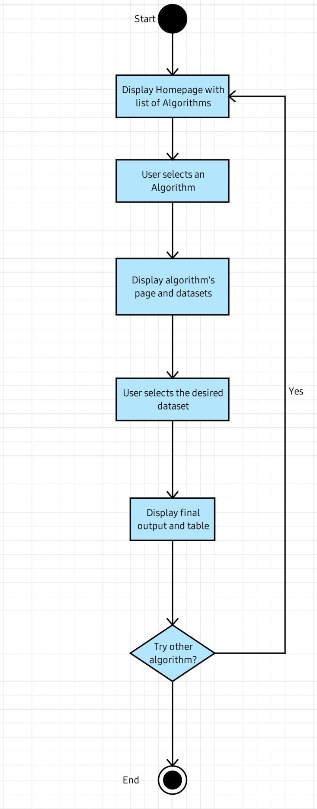

1. **Experimental Setup**

DATASETS Description and explanation.

File format

1. LCS,SCS, Edit Distance (a,b,c)

Line 1: Dataset number and length

Line 2: Sequence 1

Line 3: Sequence 2

E.g:

1. (30)

SEEHEHFSESEEEEENSNNFAEANMEEEME

AAMNEESEAAASHMEMENHASEFHMFEFSE

1. Longest Increasing Subsequence, Matrix Chain Multiplication and Partition-problem (d,e,g)

Each line represents a Dataset array to be inserted as an input.

E.g:

28, 83, 77, 34, 36, 3, 66, 54, 31, 73

1. 0/1 Knapsack (f)

Each 2 lines represents value and weights respectively for one dataset.

E.g:

8, 74, 62, 4, 42, 66, 77, 30, 25, 90, 49, 38, 15, 69, 94, 60, 18, 71, 68, 89

71, 52, 89, 83, 77, 8, 43, 26, 87, 76, 62, 10, 36, 40, 41, 46, 16, 95, 60, 53

1. Rod cutting problem (h)

Each line represents prices for different lengths of a given rod.

E.g:

8, 74, 62, 4, 42, 66, 77, 30, 25, 90, 49, 38, 15, 69, 94, 60, 18, 71, 68, 89

1. Coin Change (i)

Each line represents a Dataset array to be inserted as an input.

E.g:

28, 83, 77, 34, 36, 3, 66, 54, 31, 73, 58, 49, 100, 97, 72, 42, 98, 92, 26, 16, 21, 61, 24, 91, 67, 76

1. Word break(j)

each line represents input string to used in algorithm

e. **Results and discussion**

Problem (Rod Cutting)

Input:



Output:

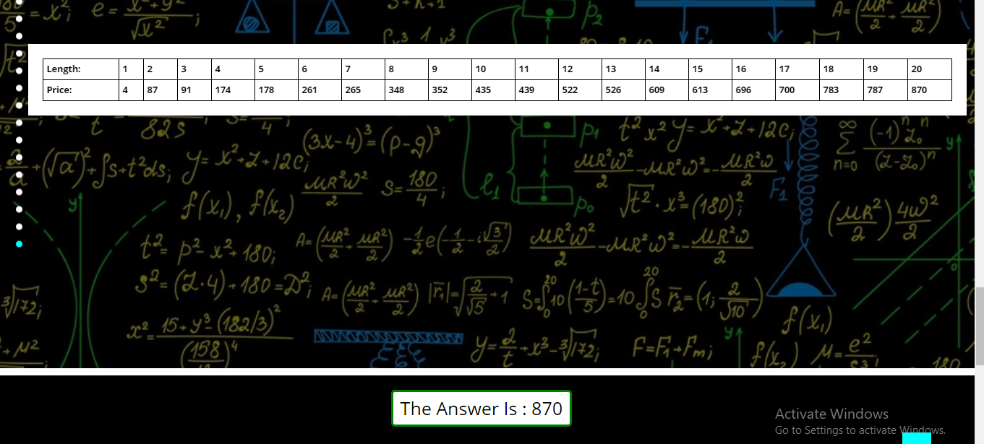

Problem (Matrix Chain Multiplication)

Input:



Output:

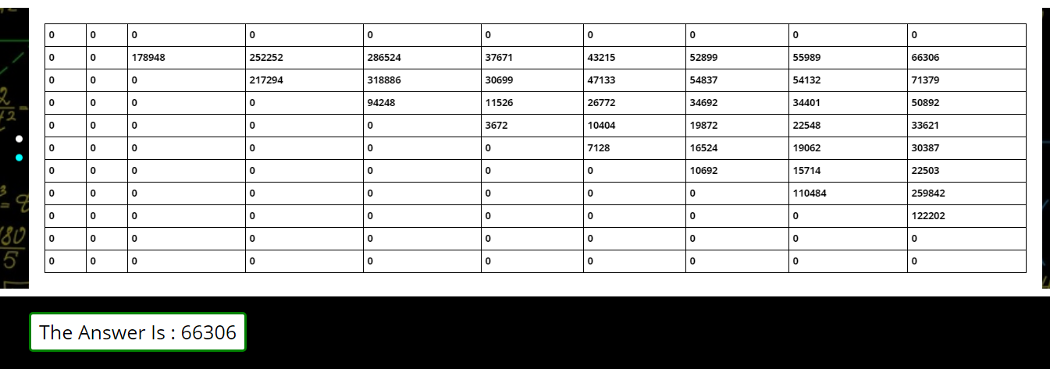

f. **Conclusion**

While many good algorithm visualizations are available,the need for more and higher quality visualizations continues. There are many topics where no satisfactory visualizations are available yet. However, there seems to be less activity for creating new visualizations now than the past ten years. While more fundamental research on how to develop and use algorithm visualizations is necessary, we also need more individuals that can produce more quality visualizations. And we need to encourage them to provide visualizations on topics which are rarely presented .This was our implementation of visualization for 10 of the most common dynamic programming algorithms. Our project can be further improved by adding features such a user inputting the data themselves and we can further add new animations. We can also make use of some framework to overall improve the performance of the application which can improve overall user experience.

g. **References**

1. <https://www.youtube.com/playlist?list=PLqM7alHXFySGbXhWx7sBJEwY2DnhDjmxm>
2. <https://www.youtube.com/playlist?list=PLJULIlvhz0rE83NKhnq7acXYIeA0o1dXb>
3. <https://www.youtube.com/playlist?list=PL_z_8CaSLPWekqhdCPmFohncHwz8TY2Go>
4. <https://www.google.com/url?sa=t&source=web&rct=j&url=https://citeseerx.ist.psu.edu/viewdoc/download%3Fdoi%3D10.1.1.105.9167%26rep%3Drep1%26type%3Dpdf&ved=2ahUKEwiXkcLqgKvuAhWJa8AKHTQVBPsQFjACegQIARAB&usg=AOvVaw32nyXzGbnGmz6UKWwEuEvv&cshid=1611162805854>